**Exp 5 Design an Automatic Night Lamp**

**Circuit Diagram**

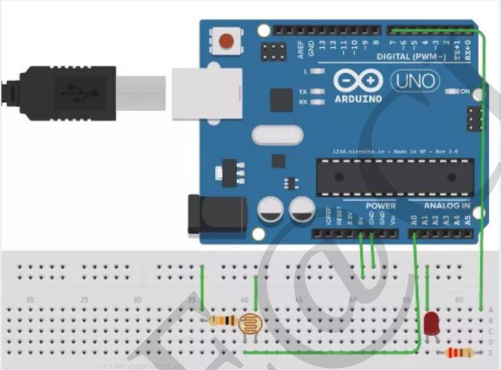

**Theory**

**Concepts Used**

1. Interfacing the LDR with the Arduino and led.
2. Blinking Of Led concept used.
3. Concept of Condition Statement used.
4. Concept of serial.begin used.
5. Concept of LDR used.

**Learnings and Observations**

In this experiment we learnt the following:

1. Basic circuit building with Arduino uno.
2. Interfacing an LDR with Arduino uno.
3. Interfacing a LDR with led and Arduino.
4. Basis principle and application of LDR.
5. As there is dark in the room the led will glow automatically.

We observe the following things:

1. When we fall the flashlight over the LDR the led will glow i.e. turn ON.
2. When we remove the flashlight over the LDR the led will stop glowing i.e. turn OFF.

**Precautions**

1. Don’t make the connection loose.
2. Before uploading the code into the Arduino make sure that the circuit is correct to avoid the damage of the circuit
3. Check the led are working or not with the help of the multimeter.
4. The LED should not be connected in reversed direction because it doesn’t allow passing the current and circuit does not completed and LED will not glow.
5. Make sure that the LDR you are using is connected properly or not and also check it is working or not.

**Learning Outcomes**

1. **We learn that how we can make an automatic night lamp with using this concept.**
2. **We also learn that how to interface a led , Arduino, and LDR in the circuit.**
3. **We also get to know the function of the “serial.begin”.**
4. **We also learn how the sensor detects whether it is dark or light.**
5. **We also learn how to blink the led with the help of LDR as it detect the dark.**